



DATABASE APPLICATIONS
(240)

State 2024
PRODUCTION
Job 1: Import/Edit Table __________ (100 points)
Job 2: Create Table __________ (50 points)
Job 3: Query/Join Tables __________ (100 points)
Job 4: Query/Report __________ (100 points)
Job 5: Report With Calculations __________ (100 points)
TOTAL POINTS __________ (450 points)

Test Time: 90 minutes

GENERAL GUIDELINES:
Failure to adhere to any of the following rules will result in disqualification:
- Member must hand in this test booklet and all printouts, if any.
- No equipment, supplies, or materials other than those specified for this event are allowed in the testing area. No previous BPA tests and/or sample tests (handwritten, photocopied, or keyed) are allowed in the testing area.
- Electronic devices will be monitored according to ACT standards.

EXAM GUIDELINES:
- Ensure this test booklet contains Jobs 1-5.
- Key all jobs according to the instructions given.
- Correct any and all formatting, spelling or grammar errors. Use the formatting guide in the Style & Reference Manual.
- Your name or initials should not appear on any work you submit. Use your Member ID in any occasion you would normally key your reference initials.
- In the lower right hand corner of ALL work submitted (unless otherwise specified), key your Member ID and job number.
- If you complete the event before the end of the time allotted, notify the proctor. Time may be considered a factor in determining a winner when there is a tie score.
- Place your scoring sheet on top of your jobs. Jobs should be placed in numerical order.

 | Points  Possible | Points  Earned
Job 1. Import/Edit Table
Table name is Alumni Imported Data – XXXXX | 10
Excel file imported correctly, including field names | 10
Added 5 new records (10 points per record) | 50
Column widths adjusted so all data is visible | 10
Total number of records is 105 | 10
Pages 7 and 8 of table printed in landscape view | 10
Total for Job 1 | 100
Job 2. Create Table
Table name is Membership Type – XXXXX | 10
Field names entered correctly (no spaces) | 10
Data entered correctly | 10
Field type for DuesAmount field is currency | 10
Export table in pdf format | 5
Print pdf in portrait orientation | 5
Total for Job 2 | 50
Job 3. Query/Join Tables
Query includes FirstName, LastName, MembershipDate, DuesPayment, MembershipType, and GraduationYear fields | 30
DuesPayment amounts of $45.00 show MembershipType of Gold, $35.00 show Silver, and $25.00 show Bronze | 40
Query sorted by last name in ascending order | 10
Query named Joined Query – XXXXXX | 10
Print in portrait orientation, with all fields on one page (total printout should be 3 pages) | 10
Total for Job 3 | 100
Job 4. Query/Report
Query includes FirstName, LastName, GraduationYear, State, DuesPayment | 10
Create stepped report from Grad Year/State/Dues query | 10
Report is grouped by Graduation Year | 20
Data within year groupings is sorted by State, then by Last Name, then by First Name | 20
Report title is Members by Graduation Year | 10
All fields and names are visible (no truncation) | 10
Removed date and page numbers from footer | 5
Inserted right footer with Member ID on one line and Job 4 on a second line | 10
Report printed in portrait orientation | 5
Total for Job 4 | 100
Job 5. Report With Calculations
Report created using query with GraduationYear, LastName, FirstName, and DuesPayment fields | 10
Report titled Dues by Graduation Year | 5
Report is grouped by Graduation Year and sorted by Last Name | 20
Report is in Stepped layout | 10
Report includes Sum and Average group calculations | 20
Report includes Grand Total calculation | 10
Fields have been resized so that all data, sums and averages are visible | 10
Removed date and page numbers from footer | 5
Inserted right footer with Member ID on one line and Job 5 on a second line | 5
Report printed in portrait orientation | 5
Total for Job 5 | 100
Total Points Earned | 450

Job 1 – Import/Edit Table (Printed only pages 7-8 of table)
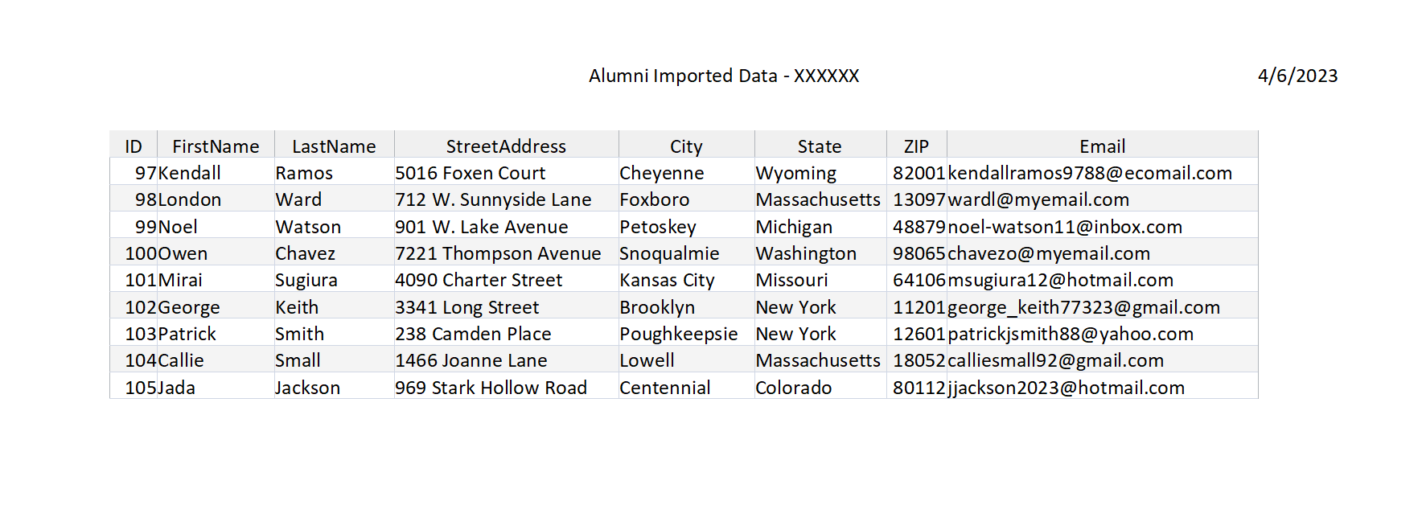
Page 7
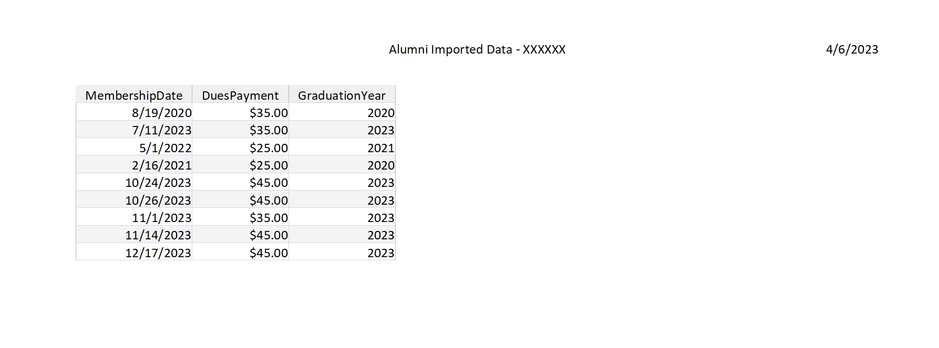
Page 8

Job 2 – Create Table/Export to PDF

Job 3 – Query/Join Tables
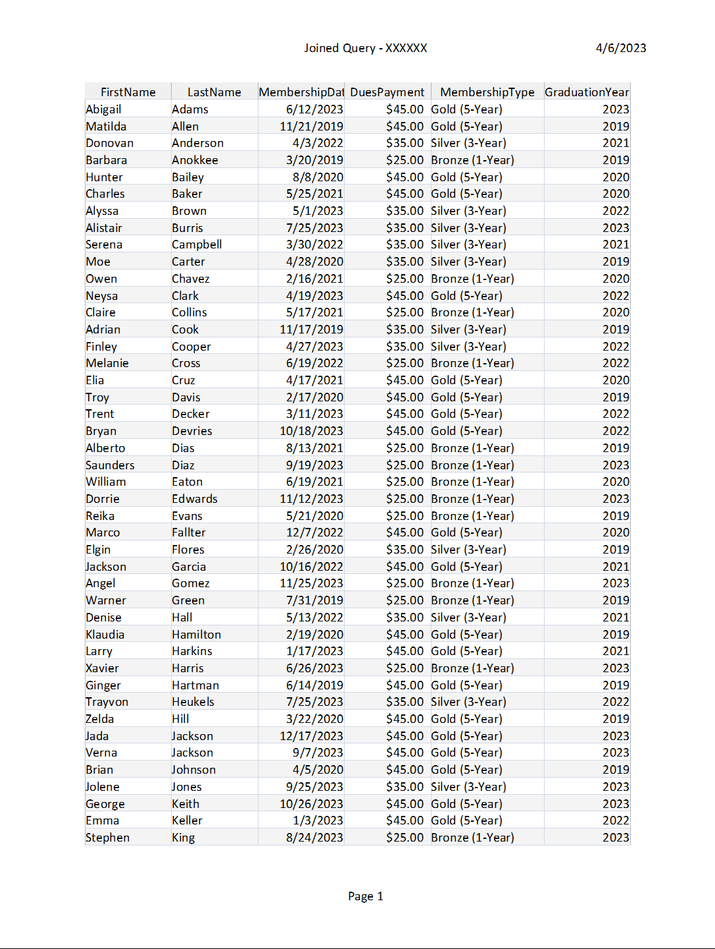

Pages 2 and 3 of Job 3 are on next page

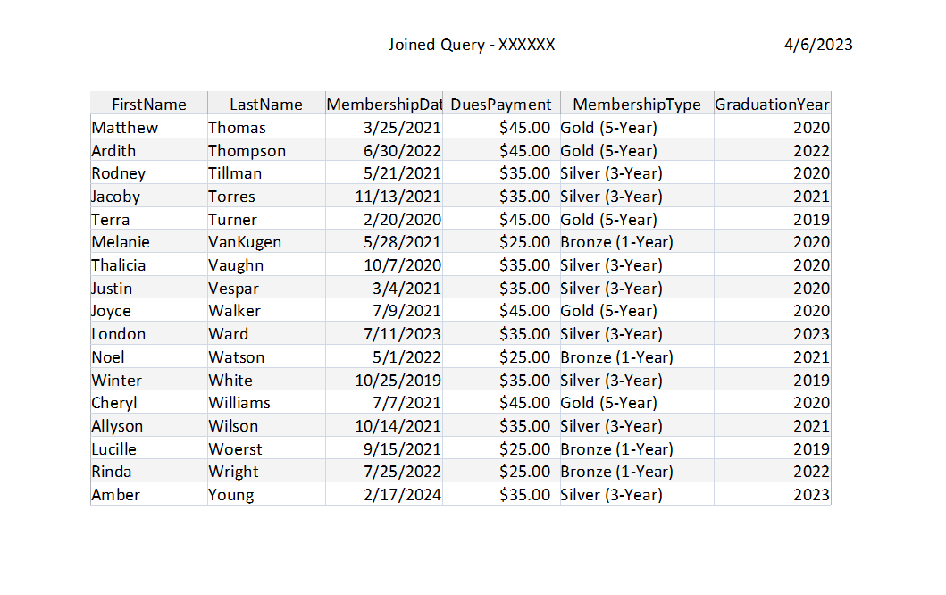
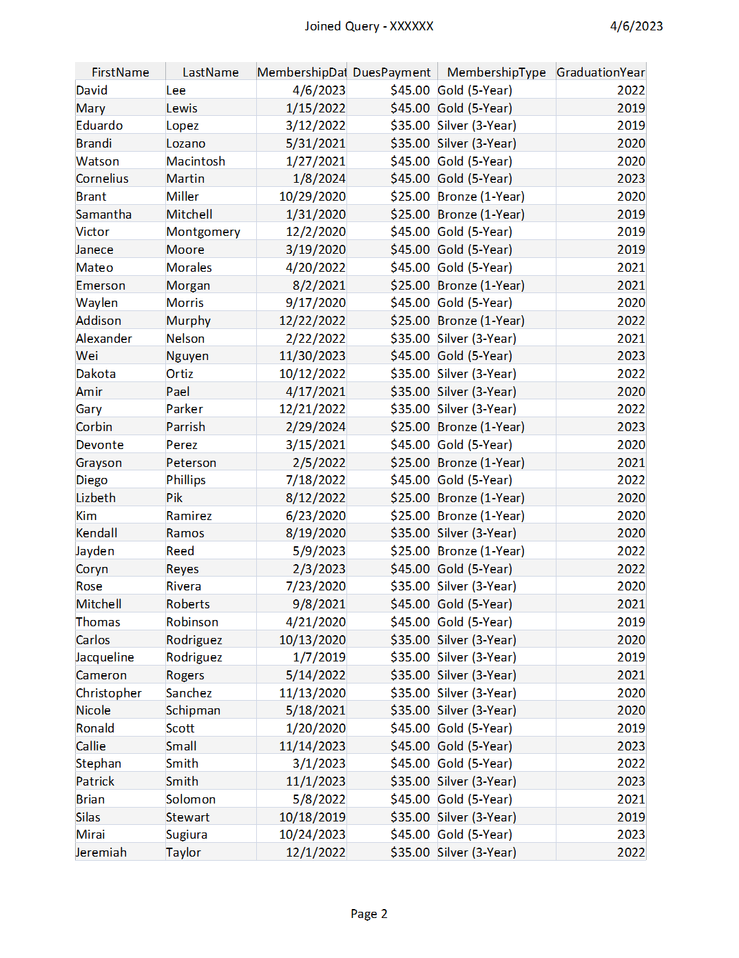

Job 4 – Query/Report

Following page is page one of report. Actual report will be three pages.

Job 5 – Report With Calculations
Four total pages
